**Dawlance LVS Air Conditioner**

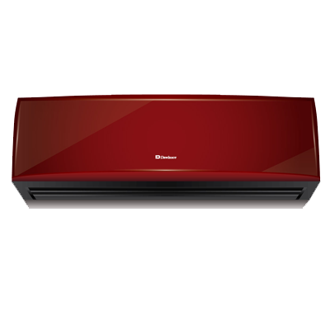

|  |  |
| --- | --- |
| **Inverter:** | Yes |
| **Capacity(tons):** | 2 |
| **Max Room Size:** | 250 sq ft. |
| **Capacity(btu/hr):** | 21,300 |
| **Power(W):** | 1200W |
| **Air Purification:** | Yes |